Chemistry Name: ________________
2020 Trial exam
120 mark total: 30 + 90
SECTION A – Multiple-choice questions

Instructions for Section A
Answer all questions.
Choose the response that is correct or best answers the question.
A correct answer scores 1, an incorrect answer scores 0.
No mark will be given if more than one answer is completed for any question.
Marks will not be deducted for incorrect answers.

Use the following information to answer Questions 1 and 2
The diagram below is a representation of the processes occurring in the production of electrical energy from coal.
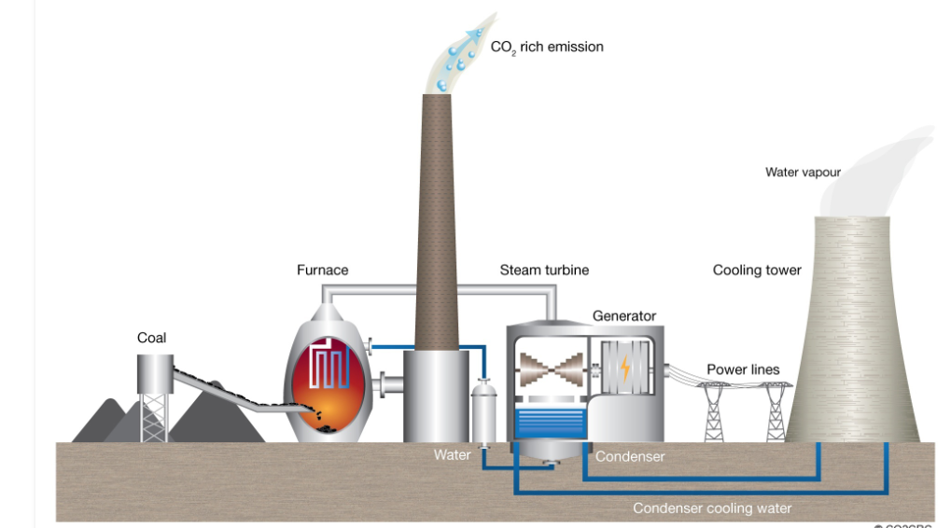

Question 1
The main energy producing reaction occurring in this power station is
A. CH₄(g) + 2O₂(g) CO₂(g) + 2H₂O(l)
B. 2C(s) + O₂(g) 2CO(g)
C. C(g) + O₂(g) CO₂(g)
D. C(s) + O₂(g) CO₂(g)

Question 2
The main pollutant producing reaction occurring in this power station is
A. CH₄(g) + 2O₄(g) CO₂(g) + 2H₂O(l)
B. C(s) + O₂(g) CO₂(g)
C. S(s) + O₂(g) SO₂(g)
D. N₂(g) + O₂(g) 2NO(g)

Question 3
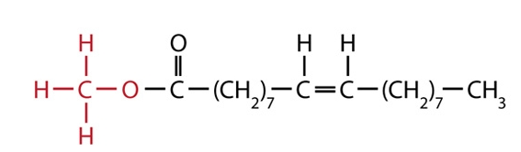
I fatty acid
II biodiesel
III ester
IV triglyceride

The molecule shown can be described as
A. I and III only.
B. II and IV only.
C. I and II only.
D. II and III only.

Use the following information to answer Questions 4 and 5
In 2019 Australia passed Qatar as the world’s largest exporter of LNG with a total export of 77.5 million tonnes (1 tonnes = 1000 kg). (Assume that LNG is 100% methane for this question)

Question 4
The amount of energy that could be produced from the complete combustion of this LNG is, in kJ,
A. 7.75×10¹³
B. 4.31×10¹²
C. 4.31×10¹⁵
D. 4.31×10¹⁸

Question 5
The volume of CO₂ that could be produced at SLC from the complete combustion of this LNG is, in L,
A. 4.84×10¹²
B. 1.2 ×10¹¹
C. 1.2 ×10¹⁴
D. 4.31×10¹⁵

Question 6
Select the alternative that best describes why the rate of a reaction increases with temperature.
A. A higher temperature means more collisions.
B. A higher temperature leads to less space between particles.
C. A higher temperature means a higher percentage of collisions are successful.
D. A higher temperature gives more collisions and a higher percentage of successful
collisions.

Question 7
The diagram below shows an energy profile diagram for a reaction with a two-stage catalyst.
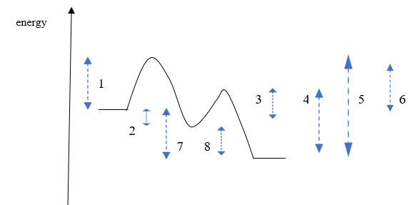
The respective values for the activation energy and enthalpy change for this reaction are
A. 1 and 7
B. 3 and 8
C. 5 and 7
D. 1 and 8

Use the following information to answer Questions 8 and 9
The diagram below shows a representation of a lithium/ manganese dioxide cell.
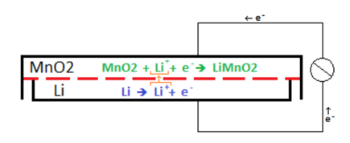

Question 8
In this cell,
A. electrons will flow from the cathode to the anode.
B. the lithium metal is the cathode and has a positive polarity.
C. lithium metal is oxidised and manganese ions reduced.
D. lithium ions are reduced and manganese ions oxidised.

Question 9
The overall reaction (simplified) for this cell will be
A. Li(s) + MnO₂(s) LiMnO₂(s) + Li⁺
B. Li(s) + MnO₂(s) LiMnO₂(s)
C. Li⁺ + MnO₂(s) + Li(s) Li⁺ + LiMnO₂(s)
D. Li⁺ + MnO₂(s) LiMnO₂(s)

Question 10
Which of these metals is the least reactive?
A. silver
B. tin
C. copper
D. lead
Question 11
Which of the following half-equations could be from the cathode of an alkaline fuel cell?
A. O₂(g) + 2H₂O(l) + 4e⁻ 4OH⁻(aq)
B. CH₄(g) + 2H₂O(l) + 4e⁻ CO₂(g) + 4OH⁻(aq)
C. H₂(g) 2H⁺(aq) + 2e⁻
D. H₂(g) + 2OH⁻(aq) 2H₂O(l) + 2e⁻

Use the following information to answer Questions 12 and 13
Aluminium metal can be recycled by dissolving the aluminium in molten cryolite and electrolysing the liquid. The half equations for the process are shown on the diagram below.

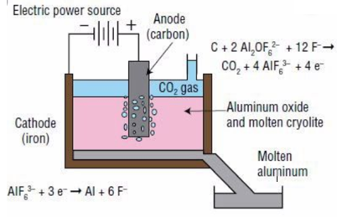

Question 12
In this cell
A. aluminium metal is formed at the anode and carbon dioxide at the cathode.
B. aluminium metal is formed at the cathode and carbon dioxide gas at the anode.
C. electrons will flow from the aluminium electrode to the carbon anode.
D. the energy released can be used to power other parts of the production process.

Question 13
A current of 10 amps runs through this cell for 10000 seconds. The volume of CO₂ produced at SLC will be, in litres,

A. 0.0064
B. 2.0
C. 6.4
D. 13

Question 14
Electrolysis of a liquid produces hydrogen gas at the negative electrode and chlorine gas at the positive electrode. The liquid could be
A. a dilute solution of HCl.
B. a dilute solution of KCl.
C. KCl(l)
D. a concentrated solution of KCl.

Use the following information to answer Questions 15 and 16
Bromine and chlorine gases can react to form the compound BrCl. The equation for the reaction is

Br₂(g) + Cl₂(g) ⇌ 2BrCl(g) K_{c} = 225 at 200 ⁰C. ΔH = -ve

Bromine is dark brown in colour. Chlorine is a very light green and BrCl colourless.

Question 15
Given the above information, what is K_{c} for the reaction BrCl(g) ⇌ ½ Br₂(g) + ½ Cl₂(g) at 200 ⁰C?
A. 0.0044
B. 0.067
C. 15
D. -225

Question 16
A change is made to an equilibrium mixture of the above gases and the brown intensity is seen to increase as equilibrium is re-established. The change could have been
A. an increase in volume.
B. the addition of further chlorine gas.
C. an increase in temperature.
D. a decrease in temperature.

Question 17
What is the systematic name of this molecule?
A. 5-chloropentan-2-ol
B. 5-chloropentanol
C. 1-chloropentan-2-ol
D. 1-chloropentan-4-ol

Question 18
The molecule shown could be formed from the reaction between
A. ethanamine and propanoic acid.
B. methanamine and propan-1-ol.
C. butanol and ammonia.
D. propanoic acid and methanamine.
Question 19
A HPLC printout for a mixture of sugars is shown below. A non-polar stationary phase has been used. The left most peak is a standard included in all mixtures.
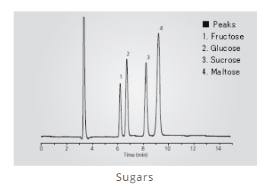

The chromatogram indicates that
A. disaccharides are more soluble than monosaccharides in the solvent used.
B. maltose is the least adsorbed on the stationary phase.
C. the concentrations of all sugars present are relatively similar.
D. monosaccharides have lower retention times than disaccharides.

Question 20

The molecule shown is tested in both proton-NMR and carbon-NMR. It will have

 | Hydrogen environments | Carbon environments
A. | 2 | 2
B. | 3 | 2
C. | 2 | 3
D. | 3 | 3

Question 21
Oxalic acid is a diprotic acid. A 15 mL aliquot of oxalic acid is neutralised by 20 mL of 3.0 NaOH. The concentration of the oxalic acid is, in M,
A. 1.0
B. 1.5
C. 2.0
D. 4.0
Question 22

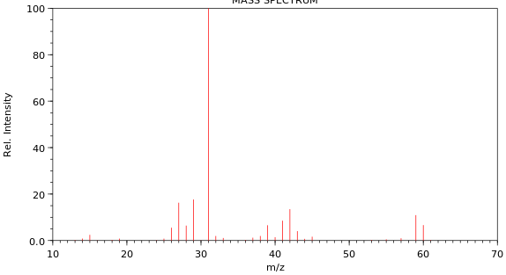
The mass spectrum shown is of
A. butane.
B. ethanoic acid.
C. propan-1-ol.
D. propan-2-ol.

Question 23
A high-resolution proton-NMR is shown below.
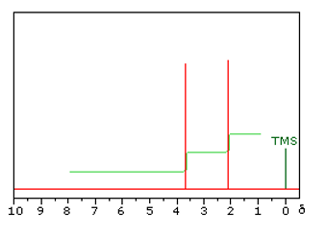

This molecule is likely to be
A. ethanol
B. propan-1-ol
C. methyl propanoate
D. methyl ethanoate

Question 24
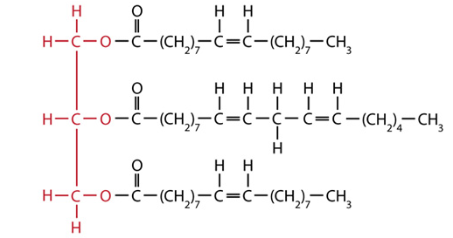
I polyunsaturated fatty acid
II monounsaturated fatty acid
III omega-3 fatty acid
IV omega-6 fatty acid
V saturated fatty acid

This triglyceride has been made from
A. I, II and III only.
B. II, IV and V only.
C. I, III and IV only.
D. I, II and IV only.

Question 25
The presence of the amino acid lysine in a protein is likely to lead to
A. dispersion forces in the tertiary structure.
B. ionic bonding in the tertiary structure.
C. covalent bonds in the tertiary structure.
D. dipole bonding in the tertiary structure.

Question 26
The molecule shown is
A. a dipeptide formed from threonine and serine.
B. an ester formed from two molecules of propan-1-ol.
C. a dipeptide formed from two molecules of serine.
D. a protein formed from threonine and serine.

Question 27
The diagram below outlines the stages in the metabolism in humans of triglycerides.
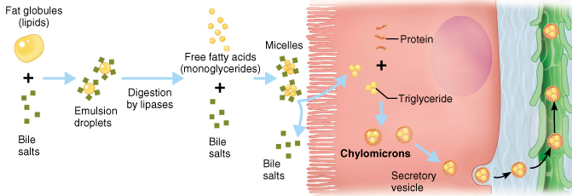
The sequence shown involves
A. fat blobs emulsified drops lipase induced hydrolysis new triglycerides.
B. fat blobs emulsified drops glycerol and glycogen fatty acids.
C. fat blobs emulsified drops lipase induced hydrolysis protein.
D. fat blobs emulsified drops fatty acid carbon dioxide and water.

Question 28
The molecule 2-amino-3-methylpentanoic acid is also known as
A. glycine.
B. isoleucine
C. leucine.
D. valine.

Question 29
A 0.64 g sample of almond is burnt under a can containing 60.0 g of water. The temperature of the water rises from 20.2 ⁰C to 28.2 ⁰C. The heat of combustion of the almond is, in kJ g⁻¹,
A. 2.01
B. 3.14
C. 2010
D. 3140

Question 30
A student conducts a titration, rinsing a pipette with deionised water. She then uses the pipette to transfer a 20.0 mL aliquot of standard base solution to flask to place under a burette. The burette contains ethanoic acid that the is attempting to determine the concentration of. The impact of this poor technique is likely to be a
A. higher titre than expected causing the calculated concentration of the acid to be high.
B. higher titre than expected causing the calculated concentration of the acid to be low.
C. lower titre than expected causing the calculated concentration of the acid to be high.
D. lower titre than expected causing the calculated concentration of the acid to be low.

SECTION B - Short-answer questions
Instructions for Section B
Questions must be answered in the spaces provided in this book.
To obtain full marks for your responses you should
- give simplified answers with an appropriate number of significant figures to all numerical questions; unsimplified answers will not be given full marks.
- show all workings in your answers to numerical questions. No credit will be given for an incorrect answer unless it is accompanied by details of the working.
- make sure chemical equations are balanced and that the formulas for individual substances include an indication of state; for example, H₂(g); NaCl(s)

Question 1 (13 marks)

The flowchart below refers to the production of biodiesel. The structure of a triglyceride is also drawn for you. The alcohol used is methanol.
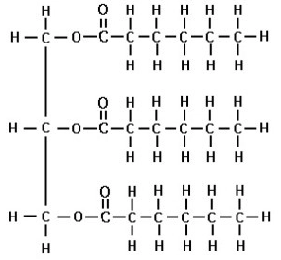
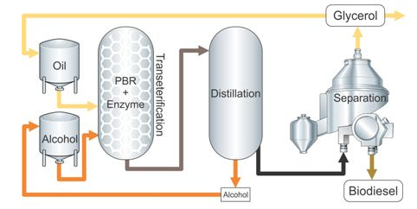

a. i. Draw the biodiesel molecule that could be formed from these raw materials. 2 marks

ii. This biodiesel molecule is a liquid at room temperature. List the two main factors
that determine the melting point of a biodiesel molecule. 2 marks

_______________________________________________________________________

_______________________________________________________________________

iii. The main reaction in this process is labelled ‘transesterification’. Explain what this
term means. 1 mark

_______________________________________________________________________

_______________________________________________________________________

b. The products of this process are biodiesel and glycerol. These molecules are both
liquids but they are easy to separate. Why are they easy to separate? 2 marks

_______________________________________________________________________

______________________________________________________________________

c. i. Write the molecular formula for the biodiesel formed ________________ 1 mark

ii. Write a balanced equation for the complete combustion of this fuel. 2 marks

_______________________________________________________________________

d. Complete the table below which is a general comparison between petrodiesel and
biodiesel. 3 marks

Property | Which is higher? Biodiesel or petrodiesel.
Viscosity
Energy density
Melting point

Question 2 (11 marks)
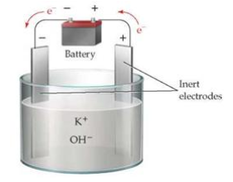
British scientist, Sir Humphry Davy, was credited as the first person to isolate the metal potassium in 1807. To do this he electrolysed molten potassium hydroxide, KOH, as shown below.

a. Use the template below to write the half-equations, then the overall equation occurring
in this cell. (You may need to refer to your Data Book to answer this question) 3 marks

Anode: _____________________________________

Cathode: _____________________________________

Overall equation: _______________________________________________
b. Any attempt to operate a large-scale version of the above process is very dangerous
without modification of the cell design.
Why is this circuit dangerous? Include a chemical equation in your answer. 2 marks

_______________________________________________________________________

_______________________________________________________________________

c. Calculate the mass of potassium Davy would have isolated using a current of 0.23 amps
for 20 minutes. 3 marks

_______________________________________________________________________

_______________________________________________________________________

_______________________________________________________________________

d. If Davy had used a dilute solution of KOH, the products would not have been the same.
Complete the template for the half-equations and overall equation for the electrolysis of
KOH(aq). 3 marks

Anode: _____________________________________

Cathode: _____________________________________

Overall equation: _______________________________________________

Question 3 (9 marks)
The empirical formula of a molecule is found to be C₄H₁₀O.

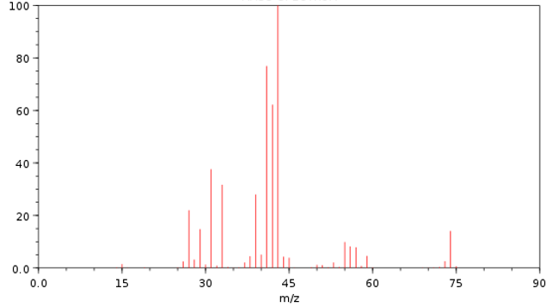

a. The mass spectrum of the molecule is shown above.
Use the mass spectrum to

i. determine the molecular formula of the molecule. ___________ 1 mark

ii. suggest a fragment that might have caused the base peak. ___________ 1 mark

b. The infrared spectrum of the molecule is shown below.
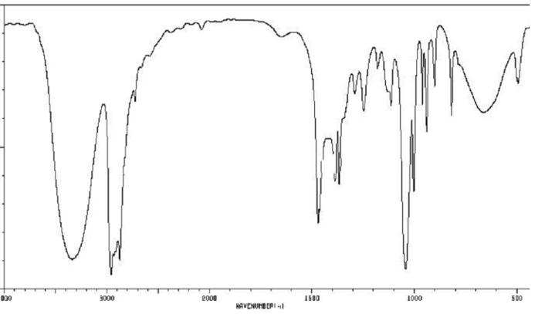

What conclusions can you draw from this spectrum? 2 marks

____________________________________________________________________

____________________________________________________________________
c. Draw two possible structures for this molecule. 2 marks

d. The carbon-NMR of the molecule is shown below.

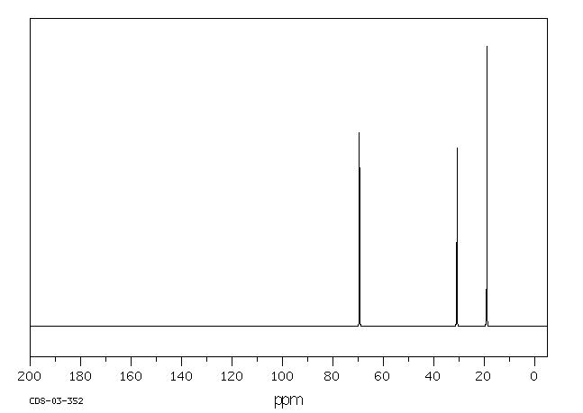

Use this spectrum to name the molecule in question. Explain how the carbon-NMR
structure provided is consistent with your choice. 3 marks

____________________________________________________________________

____________________________________________________________________

____________________________________________________________________

____________________________________________________________________

Question 4 (8 marks)
The cell shown below is a fuel cell using ethanol solution and oxygen gas as reactants. The reaction produces CO₂ gas which in turn forms carbonate ions in the solution. The half-equation and voltage for the reaction of the ethanol is

C₂H₅OH(aq) + 16OH⁻(aq) 2CO₃²⁻(aq) + 11H₂O(l) + 12e⁻ -0.74 V
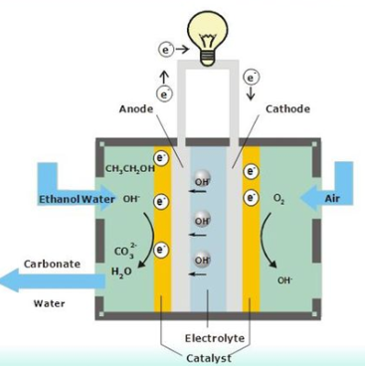

a. Use the circles provided to indicate the polarity of the electrodes. 1 mark

b. i. Use the template provided to write the oxygen half-equation and the overall equation
for this cell.

Oxygen half-equation: ___________________________________ 1 mark

Overall equation: ____________________________________ 1 mark

ii. What will be the cell voltage of this cell? __________________ 1 mark

iii. Calculate the energy is released by the reaction of 1 mol of ethanol? 2 marks

______________________________________________________________________

c. Energy can also be produced by the direct combustion of ethanol. 2 marks
List two advantages of the use of an ethanol fuel cell over direct combustion of ethanol.

_____________________________________________________________________

_____________________________________________________________________

Question 5 (9 marks)
a. The two molecules shown are structural isomers. They are both colourless liquids.
___________________ _________________

i. Use the lines provided to name each molecule. 2 marks

ii. Describe a chemical test or reaction that could be used to distinguish between the two
liquids. Explain briefly how your test works. 2 marks

____________________________________________________________________

____________________________________________________________________

iii. Which spectrum should easily distinguish the two molecules? 1 mark

____________________________________________________________________
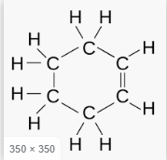
b. The two molecules shown are both fuels and are both colourless liquids.
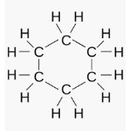

Describe carefully a chemical test that will distinguish the two liquids. Explain briefly
how your test works. 2 marks

____________________________________________________________________

____________________________________________________________________

c. The two molecules shown are both colourless liquids

Describe carefully a chemical test that will distinguish the two liquids. Explain briefly
how your test works. 2 marks
____________________________________________________________________

____________________________________________________________________

Question 6 (8 marks)
Hydrogen and iodine gases react to form hydrogen iodide:

H₂(g) + I₂(g) ⇌ 2Hl(g) ΔH < 0

a. The volume of an equilibrium mixture of the above gases is decreased. Explain the
impact of this change on

i. the value of the equilibrium constant. 1 mark

_______________________________________________________________________

ii. the concentration of HI gas. 2 marks

________________________________________________________________________

________________________________________________________________________

iii. the amount of HI gas. 1 mark

________________________________________________________________________

_________________________________________________________________________

iv. the rate of the forward reaction 1 mark

________________________________________________________________________

_________________________________________________________________________

b. 0.60 mol of HI is added to an empty 2.0 L reactor at 80 ⁰C. At equilibrium the amount of
hydrogen gas is found to be 0.15 mol.
Calculate the value of the equilibrium constant at 80 ⁰C. 3 marks

________________________________________________________________________

_________________________________________________________________________

________________________________________________________________________

_________________________________________________________________________

Question 7 (8 marks)
The apparatus below is used to determine the heat of combustion of an almond.
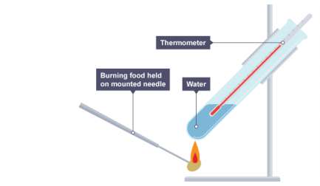

Mass of water: 80 g

Mass of almond: 0.42 g

Initial temperature water: 22 ⁰C

Final temperature water: 48 ⁰C

a. Use the data provided to calculate the per gram heat of combustion of the almond.
3 marks
_______________________________________________________________________

_______________________________________________________________________

_______________________________________________________________________

b. The experiment shown above usually results in low estimates for heats of combustion.
i. If the composition of the almond is assumed to be 70% oil and 30%carbohydrate what
would the theoretical heat of combustion be? 1 mark

_______________________________________________________________________

ii. Discuss reasons for the low results. 2 marks

_______________________________________________________________________

_______________________________________________________________________

c. Write a balanced equation for the complete combustion of glucose. 2 marks

________________________________________________________________________

Question 8 (8 marks)
a. Many soft drinks offer a ‘normal’ version with sugar and an alternative ‘diet’ version
using artificial sweeteners. Discuss the chemistry of this marketing. 2 marks

______________________________________________________________________

_______________________________________________________________________

_______________________________________________________________________

b. Many biomolecules are large molecules. Complete the template below by
- identifying in the second column the smaller molecule(s) used to form the food.
- listing in the third column an enzyme that plays a role in the metabolism of that
biomolecule. 3 marks
 | Building block(s) | Enzyme aiding metabolism
Carbohydrate
Protein
Triglyceride

c. i. What is a vitamin? 1 mark

____________________________________________________________________

ii. Vitamins are generally placed in two categories. Name the two categories and what
chemical feature is generally responsible for this categorisation? 2 marks

____________________________________________________________________

____________________________________________________________________

____________________________________________________________________
Question 9 (8 marks)
When you cook eggs the egg white, albumin, turns white. The albumin is a protein and the heat used during cooking causes it to denature. The addition of vinegar aids the denaturing process.

A student conducts an investigation into this process. An outline of her experimental procedure is shown in italics below.

Investigation: To conduct an experiment where eggs are cooked at different temperatures and the time it takes for the eggs to cook is recorded and studied.
Hypothesis: The rate at which an egg cooks will increase with temperature up to a point but then will drop as the protein denatures.

Procedure
1. Prepare several beakers containing 50 mL of 1.0 M ethanoic acid.
2. Heat each beaker to a different temperature.
3. Add an egg to each beaker and record the time it takes for the outside of the egg to turn
completely white.

Results
Temperature ⁰C | Time to cook (secs)
30 | Over 10 minutes
40 | 812
50 | 420
60 | 250
70 | 146
80 | 88
90 | 52

Conclusion
The denaturing of egg is not typical of normal enzymes – the rate does not slow at high temperatures.

a. For the student’s experiment, state the
i. independent variable _____________________________ 1 mark

ii. dependent variable ______________________________ 1 mark

iii. a controlled variable. _____________________________ 1 mark

b. Suggest an important reason why multiple trials will improve the reliability of the results
obtained in this experiment. 1 mark

_______________________________________________________________________

c. Use your knowledge of proteins to explain what is happening to the bonding in egg white
as it is heated. 2 marks

_______________________________________________________________________

_______________________________________________________________________

_______________________________________________________________________

d. Discuss the student’s conclusion. 2 marks

_______________________________________________________________________

_______________________________________________________________________

Question 10 (8 marks)
Many nutritionists consider hemp seeds to be a superfood. Hemp seeds come from the Cannabis sativa plant but they do not produce a mind-altering effect. They are a small, brown seed, rich in protein, fibre and fatty acids.

a. Hemp oil contains high proportions of essential fatty acids.
Use your knowledge of biomolecules to explain what essential fatty acids are and what
characteristics their structures have. 3 marks

___________________________________________________________________

___________________________________________________________________

___________________________________________________________________

___________________________________________________________________

___________________________________________________________________

___________________________________________________________________

b. Hemp seeds are one of the few foods considered to be a ‘complete source of protein’.
This means they provide all essential amino acids.

Use your knowledge of biomolecules to explain the significance of a food being
classified as ‘complete source of protein’. 3 marks

___________________________________________________________________

___________________________________________________________________

___________________________________________________________________

___________________________________________________________________

c. Hemp seeds are high in fibre. What is fibre and what happens to fibre when consumed by
humans? 2 marks

___________________________________________________________________

___________________________________________________________________

___________________________________________________________________

___________________________________________________________________

Section A 30 marks ____

Total Section B 90 marks ____

Total exam 120 marks ____

END OF EXAM

